İD:2107346

Name/Surname: Barış Karapelit

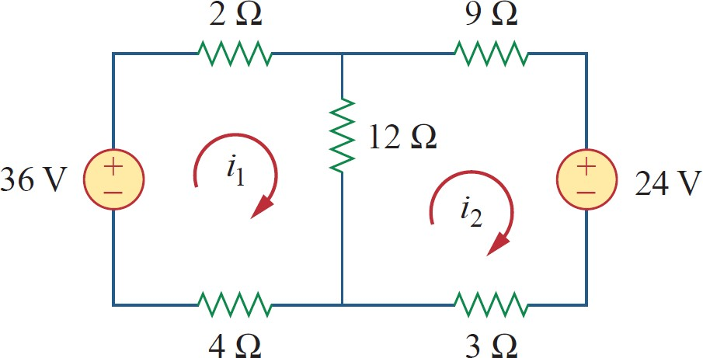 Find the mesh currents i1, and i2.



I1 = i2+ i3

I3 = i1 – i2

-36 + 2.i1 + 12.i3 + 4i1 =0

-36 + 2i1 + 12( i1 – i2) + 4i1=0

18i1 – 12i2 = 36 …………. Eq 1

+ 24 + 3i2 -12(i3) + + 9i2 =0

+ 3i2  -12(i1-i2) + 9i2 = -24

+ 3i2 – 12i1+12i2 + 9i2 = - 24

-12i1 + 24i2 = -24 …………………. Eq2

2[18i1-12i2 = 36 ] => 36i1-24i2 = 72

3[-12i1 + 24i2 = -24 ] => -36i1 + 72i2 = -72

---------------------------- ------------------------

48i2=0 i2=0 18i1-12.0 = 36 => i1 =2